**INTRODUCTION**

**Problem Description:-**

Live streaming has a charm to it. People stick to watching it for long without

batting their eyelids.

But, just when you start getting into the sync with the live stream does that

dreaded thing starts to happen! Buffering. The small rounded dots that

seems to go on forever.

“Why does my video keep buffering?”

At least one-half of viewers who watched a live stream swear ask this

question helplessly. video streaming issues can be caused by many factors.

By troubleshooting your internet ordevice connection, you may be able to

play your videos again.

There are 5 common reasons that causes buffering issues:

1. The connection between the live video encoder and the server is interrupted.

2. The Internet connection speed is inadequate to accommodate the encoder’s bitrate.

3. Extinguishing the bitrate available for live streaming.

4. Excess load on the server making it to crash.

5. The Internet bandwidth maybe inadequate to push the live stream completely.

**Domain Knowledge:-**

This video streaming project is very unique and different in its approach when compared to the existing projects in the video -streaming segment. It provides feature to access open entrainment. Video streaming website is changing the mode of establishing the piece of information to every device connected to networks globally. Video Streaming and broadband connections help users around the globe , watch large video files from the comfort of their homes and gadgets.  For today’s audiences it’s all about immediacy and mobility, the content they are looking for must be just a click away to fit their needs.  Now everything is possible. If you want to watch an episode of your favorite show when you are traveling, or if each member of your family wants to watch something different in a separate room of the house.

All these demands are being fulfilled with the help of video streaming as well as the devices that gives the user access to it.

Video Upload facility is also provided to the user, so that each video is available to everyone.

PDF of books are added to the website, to provide total entertainment to user.

PHP is used to provide dynamic access to the website.

**Project Aim and Objective:-**

Aim: To develop “VRS (video streaming)” website using PHP programming language.

- A video streaming service is an on demand online entertainment source for TV shows,

movies and other streaming media.

- The project also contain different book section for the readers.

- There are limited videos store in this website so that user can watch videos without

internet.

- User can share there videos with others through sharing the links.

The project VRS ultimate classic help users around the globe download and watch large video files from the comfort of their homes or anywhere.

The objective of the video streaming is to provide the videos to the user for the entertainment purpose. There are different section in this website so that user can easily go through any of them. In addition to that we have also added the book section on the website , so that if user get bored he/she can go through the books.

The database is included in the “VRS (video streaming) system. The database is used for storing the videos.

**Scope of the Project:-**

Online web streaming is one of the most popular Internet activity. Whether you want to watchvideo from across the world, news recaps, TV shows, tutorials, or funny videos guaranteed to find something you like at one of the top five video streaming websites.In future there will be online broadcasting will be available in this system.

**Operation Environment:-**

Operation environment for the VRS (video streaming) website are listed below :

▪ Distributed database

▪ Client/server system

▪ Operating system: Windows.

▪ Database: mysql+ database

▪ Platform: html/PHP.

**SYSTEM STUDY**

**Software Requirement Specification:-**

A Software requirements specification(SRS) document describes the intended purpose, requirements and nature of a software to be developed. It also includes the yield and cost of the software.

The SRS will provide a detailed description of the requirements for the Video streaming website. The purpose of this document is to build online video streaming website. The video streaming websites are on demand online entertainment source for movies, cartoons and other streaming media. Online web streaming is one of the most popular Internet activity. Whether you want to watch video from across the world, news recaps, TV shows, tutorials, or funny videos, guaranteed to find something you like at one of the top five video streaming websites.

This software is developed in html and php programming language. The database are createdusing php to store the videos.

**Existing system:-**

In existing system we first have to select the plans then it going shows as the videos. In this project there is no plans so user only have to login to our website. Sometimes we have pay for the plans but in this project, we don’t have such facility. The existing system does not have the option of books, in this system we have the option of the books in case if user get tired of watch video he can go through the books. In this system login and register page contain four videos sothat before user going to login he/she can go through the videos, so such facility does notavailable in existing system.

When user go to this system there were already four videos were present, so user can go through that and then further he/she can login or register. Such facility is not able in the existing system. In the existing system user have to download the video to see it without internet. In this system there were already videos are present only user have to login to the page , then he/she can see the videos without internet.

**Proposed System:-**

Video Streaming is a web based application allow the users to browse the videos, and at same time user can also upload the video.. In this we have provided channels with different categories.

We have added a book section in the video streaming. In this if user get bored my watching the video then user can read the books online. In the video streaming user can share their videos with other user by sharing the links. In our project we have used php code and with help of html we design the web page. Some additional feature which have been added to make the project more interactive are uploading the videos and sharing videos using embedded links. In this system user can just login to our website and register for an event slot post which confirmation mail will be sent and they can watch the video according to their choices. When user go through login and register page he will come to see there were already four videos are presented so that user can go through that video also.

The user can then share the invitation to all the participants from their registered ID. In this system user will also have the favorite section to store their favorite videos. Live streaming is not available in this system. This system contain limited videos user can go through extended videos in the system by uploading the videos.

**Software Tool Used:-**

PHP:- PHP code may be executed with a [command line interface](https://en.wikipedia.org/wiki/Command-line_interface) (CLI), embedded into [HTML](https://en.wikipedia.org/wiki/HTML) code, or it can be used in combination with various [web template systems](https://en.wikipedia.org/wiki/Web_template_system), web content management systems, and [web frameworks](https://en.wikipedia.org/wiki/Web_framework). PHP code is usually processed by a PHP [interpreter](https://en.wikipedia.org/wiki/Interpreter_(computing)) implemented as a [module](https://en.wikipedia.org/wiki/Plugin_(computing)) in a web server or as a [Common Gateway Interface](https://en.wikipedia.org/wiki/Common_Gateway_Interface) (CGI) executable. The web server combines the results of the interpreted and executed PHP code, which may be any type of data, including images, with the generated web page.

Hypertext Markup Language (HTML) is the standard [markup language](https://en.wikipedia.org/wiki/Markup_language) for creating [web pages](https://en.wikipedia.org/wiki/Web_page) and [web applications](https://en.wikipedia.org/wiki/Web_application). With [Cascading Style Sheets](https://en.wikipedia.org/wiki/Cascading_Style_Sheets) (CSS) and [JavaScript](https://en.wikipedia.org/wiki/JavaScript), it forms a triad of [cornerstone](https://en.wikipedia.org/wiki/Cornerstone) technologies for the [World Wide Web](https://en.wikipedia.org/wiki/World_Wide_Web).

Cascading Style Sheets (CSS) is a [style sheet language](https://en.wikipedia.org/wiki/Style_sheet_language) used for describing the [presentation](https://en.wikipedia.org/wiki/Presentation_semantics) of a document written in a [markup language](https://en.wikipedia.org/wiki/Markup_language) like [HTML](https://en.wikipedia.org/wiki/HTML).[[1]](https://en.wikipedia.org/wiki/Cascading_Style_Sheets#cite_note-1) CSS is a cornerstone technology of the [World Wide Web](https://en.wikipedia.org/wiki/World_Wide_Web), alongside HTML and [JavaScript](https://en.wikipedia.org/wiki/JavaScript).

JavaScript is a [high-level](https://simple.wikipedia.org/wiki/High-level_programming_language), interpreted [programming language](https://simple.wikipedia.org/wiki/Programming_language) for [computers](https://simple.wikipedia.org/wiki/Computer). It is often run in [web browser](https://simple.wikipedia.org/wiki/Web_browser) applications to create things that work by themselves like a popup message or a live [clock](https://simple.wikipedia.org/wiki/Clock). It is not related to the [programming language](https://simple.wikipedia.org/wiki/Programming_language) [Java](https://simple.wikipedia.org/wiki/Java_programming_language).

**SYSTEM ANALYSIS AND DESIGN**

**Software Requirement:-**

* Operating System : Windows XP and above.
* Tools : Dreamweaver/Notepad++
* Language used : Php,Html,css
* Database Used : MYSQL Server

**Hardware Requirement:-**

* Processor : Processor with speed more than 1.5Ghz
* RAM : 512 MB and above
* Hard disk : Minimum 40 GB and above
* Input Device : Mouse or Keyboard

**Flowchart:-**

News

Movies

Music

Sports

Trending

Videos of the choice

Play Video

numbar

Log out

Log in

Category list

Registration

Cartoon

Read choice

numbar

**Algorithm:-**

Step1: Start.

Step 2:Log_in if not then, go for registration.

Step3:For registration take values

(first_name, last_name, DOB,contact_number,Email_id)

Print choices: 1.Cartoon 2.Movies 3.Music 4.Sports 5.News 6.Trending.

Step 4:If 1, Open cartoon videos.

Step 5: Select and play video.

Step 6: If 2, Open movie video.

Step 7: Select and play video.

Step 8: If 3, Open music videos.

Step 9: Select and play video.

Step 10: If 4, Open sports videos.

Step 11: Select and play video.

Step 12: If 5, Open news videos.

Step 13: Select and play video.

Step 14: If 6, Open trending videos.

Step 15: Select and play video. Step 16: Stop.

**Data Flow Diagram:-**

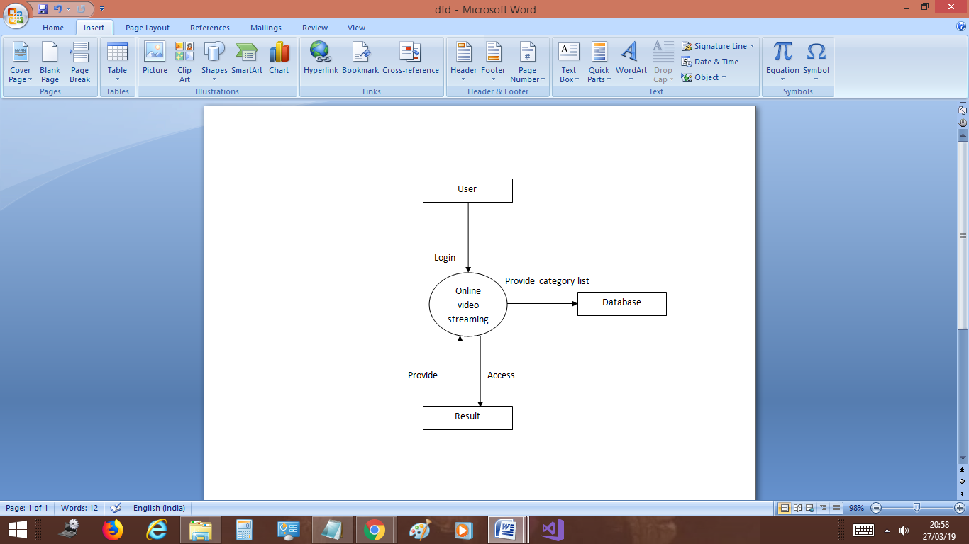

**Estimation and Planning:-**

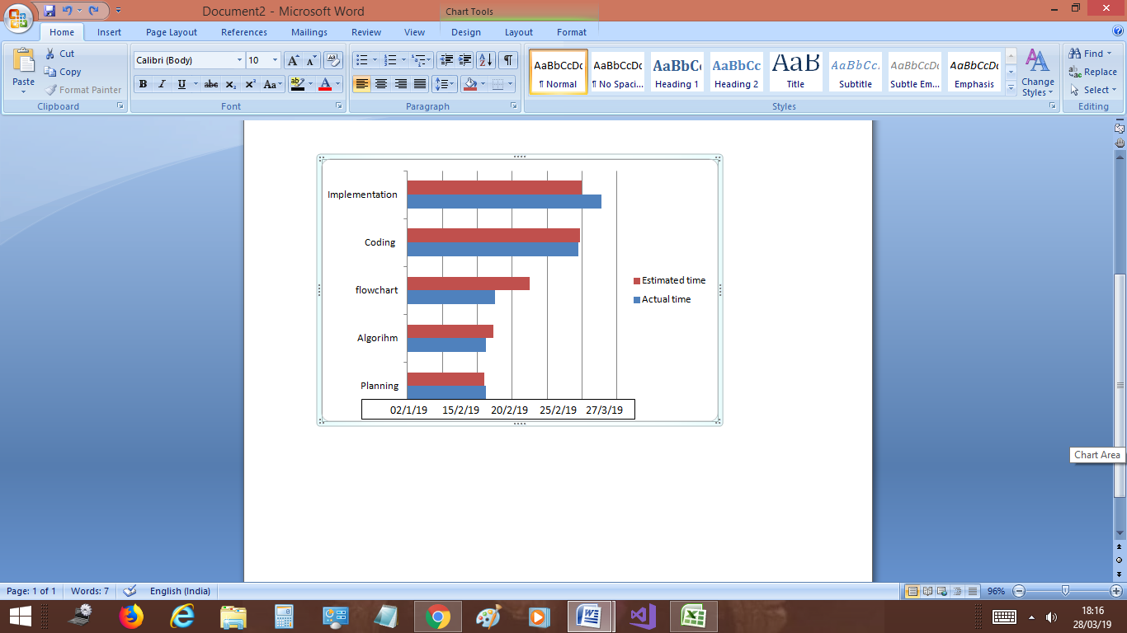

**SYSTEM IMPLEMENTATION**

**Module Description:-**

Registration:-This module is used for creating account in our website by accepting the basic information like name, phone no, email id, address and password and create account. After registration user will get an unique login id and password to login to the website at his/her next visit. After the process is completed user will have facility to watch video as per the chosen category.

Channel:-In this module user will get different videos of different categories. The channels are named as categories. The types of channels are music, sports, news, carton, movies, trending and books. Each channel will contain number of videos to be streamed by the user.

Search:- User can search for the particular video through traversal method. The user will have to seek for the category the video belongs to, and have to search for the particular video manually. In this way there is no mistakes of typing wrong words and missing the data.

Video streaming:-Video streaming is a module to access through the videos provided inside the categories. The user can watch, play,pause, fast forward the video and can traverse to the next and pervious video in one click. user can start video from any point by seeking.

Share link:-The user can share the link of the video or the website with anyone by copying the URL from above the webpage and sending it to the friends or needy. Direct sharing will be available once the site is updated.

**Source Code:-**

Homeframe.html:-

<html>

<head>

<title> home frame </title>

<meta charset="utf-8">

<meta http-equiv="X-UA-Compatible" content="IE=edge">

<meta name="viewport" content="width=device-width, initial-scale=1.0">

</head>

<frameset rows="20%,50%,30%" border="0" width="100%">

<frame src="home1.html" scrolling="no">

<frame src="home2video.html">

<frame src="home3.html" scrolling="no">

</frameset>

</html>

Home1.html:-

<html>

<head>

<title> home frame </title>

<style>

body

{ font-family:Baskerville Old Face;

text-align: center; }

span.one

{ text-align: center;

color: white;

font-size: 200px; }

span.two

{ text-align: center;

color: white;

font-size: 50px; }

</style>

</head>

<body bgcolor="#154360">

<span class="one">

VRS

<span class="two">

ULTIMATE CLASSIC

</span>

</span> </body> </html>

Home2videos:-

<html>

<head>

<title> home frame </title>

<style>

h1

{ text-align: center;

color:blue;

font-size: 30px; }

</style>

</head>

<body bgcolor="#EAECEE">

<br><br>

&nbsp;&nbsp;&nbsp;&nbsp;&nbsp;&nbsp;&nbsp;&nbsp;&nbsp;&nbsp;&nbsp;&nbsp;&nbsp;&nbsp;&nbsp;&nbsp;&nbsp;&nbsp;&nbsp;&nbsp;&nbsp;&nbsp;&nbsp;&nbsp;&nbsp;&nbsp;&nbsp;&nbsp;&nbsp;&nbsp;&nbsp;&nbsp;&nbsp;&nbsp;&nbsp;&nbsp;&nbsp;&nbsp;&nbsp;&nbsp;&nbsp;&nbsp;&nbsp;&nbsp;&nbsp;&nbsp;&nbsp;&nbsp;

<embed src="C:\wamp\www\VRS frames\front videos\videoplayback (3).mp4" autostart="false" height=450 width=525>

&nbsp;&nbsp;&nbsp;&nbsp;&nbsp;&nbsp;&nbsp;&nbsp;&nbsp;&nbsp;&nbsp;&nbsp;&nbsp;&nbsp;&nbsp;&nbsp;&nbsp;&nbsp;&nbsp;&nbsp;&nbsp;&nbsp;&nbsp;&nbsp;

<embed src="C:\wamp\www\VRS frames\front videos\videoplayback.mp4" autostart="false" height=450 width=525>

&nbsp;&nbsp;&nbsp;&nbsp;&nbsp;&nbsp;&nbsp;&nbsp;&nbsp;&nbsp;&nbsp;&nbsp;&nbsp;&nbsp;&nbsp;&nbsp;&nbsp;&nbsp;&nbsp;&nbsp;&nbsp;&nbsp;&nbsp;&nbsp;

<embed src="C:\wamp\www\VRS frames\front videos\videoplayback (1).mp4" autostart="false" height=450 width=525>

&nbsp;&nbsp;&nbsp;&nbsp;&nbsp;&nbsp;&nbsp;&nbsp;&nbsp;&nbsp;&nbsp;&nbsp;

&nbsp;&nbsp;&nbsp;&nbsp;&nbsp;&nbsp;&nbsp;&nbsp;&nbsp;&nbsp;&nbsp;&nbsp;

<embed src="C:\wamp\www\VRS frames\front videos\videoplayback (2).mp4" autostart="false" height=450 width=525>

&nbsp;&nbsp;&nbsp;&nbsp;&nbsp;&nbsp;&nbsp;&nbsp;&nbsp;&nbsp;&nbsp;&nbsp;&nbsp;&nbsp;&nbsp;&nbsp;&nbsp;&nbsp;&nbsp;&nbsp;&nbsp;&nbsp;&nbsp;&nbsp;

<br>

<h1 align="center"> Maari 2

&nbsp;&nbsp;&nbsp;&nbsp;&nbsp;&nbsp;&nbsp;&nbsp;&nbsp;&nbsp;&nbsp;&nbsp;&nbsp;&nbsp;&nbsp;&nbsp;&nbsp;&nbsp;&nbsp;&nbsp;&nbsp;&nbsp;&nbsp;&nbsp;

&nbsp;&nbsp;&nbsp;&nbsp;&nbsp;&nbsp;&nbsp;&nbsp;&nbsp;&nbsp;&nbsp;&nbsp;&nbsp;&nbsp;&nbsp;&nbsp;&nbsp;&nbsp;&nbsp;&nbsp;&nbsp;&nbsp;&nbsp;&nbsp;&nbsp;&nbsp;&nbsp;&nbsp;&nbsp;&nbsp;&nbsp;&nbsp;&nbsp;&nbsp;&nbsp;&nbsp;

Shamjhawan

&nbsp;&nbsp;&nbsp;&nbsp;&nbsp;&nbsp;&nbsp;&nbsp;&nbsp;&nbsp;&nbsp;&nbsp;&nbsp;&nbsp;&nbsp;&nbsp;&nbsp;&nbsp;&nbsp;&nbsp;&nbsp;&nbsp;&nbsp;&nbsp;&nbsp;&nbsp;&nbsp;&nbsp;&nbsp;&nbsp;&nbsp;&nbsp;&nbsp;&nbsp;&nbsp;&nbsp;&nbsp;&nbsp;&nbsp;&nbsp;&nbsp;&nbsp;&nbsp;&nbsp;&nbsp;&nbsp;&nbsp;&nbsp;&nbsp;&nbsp;&nbsp;&nbsp;

Too Good At Goodbyes- Sam Smith

&nbsp;&nbsp;&nbsp;&nbsp;&nbsp;&nbsp;&nbsp;&nbsp;&nbsp;&nbsp;&nbsp;&nbsp;&nbsp;&nbsp;&nbsp;&nbsp;&nbsp;&nbsp;&nbsp;&nbsp;&nbsp;&nbsp;&nbsp;&nbsp;

Let Her Go- Passenger

</h1>

</body>

</html>

Home3.html:-

<html>

<head>

<title> home frame </title>

<style>

body

{ font-family:Baskerville Old Face;

text-align: center; }

.click {

background-color: #ffffff;

border: outset;

color: black;

padding: 10px 20px;

text-align: center;

text-decoration: none;

display: inline-block;

font-size: 40px; }

</style>

</head>

<body bgcolor="#154360">

<h2>

<br> <br> <br> <br>

<a href="login1.html" class="click" target="blank"> LOGIN </a>

<br> <br> <br>

<a href="registration1.html" class="click" target="blank"> REGISTER </a> </h2> </body> </html>

Login1.html:-

<html>

<head>

<title> login </title>

<script type="text/javascript">

function validate()

{ if(document.login.uname.value=="")

{alert("Enter a valid User Name!");

document.login.uname.focus(); }

else if(document.login.pass.value=="")

{alert("Enter Password!");

document.login.uname.focus(); } }

</script>

<style>

body

{ font-family:Baskerville Old Face;

text-align: center;

font-size:20px; }

h1

{color:white;

font-size:70px;}

.button

{ background-color: #ffffff;

border: none;

color: black;

font-family:Baskerville Old Face;

padding: 15px 32px;

text-align: center;

text-decoration: none;

display: inline-block;

font-size: 55px; }

.button1 {

background-color: #ffffff;

border: none;

color: black;

padding: 10px 20px;

text-align: center;

text-decoration: none;

display: inline-block;

font-size: 45px; }

.button2 {

border: none;

color: white;

padding: 10px 20px;

text-align: center;

display: inline-block;

font-size: 45px; }

h3

{ font-size:40;

color:white; }

</style>

</head>

<body align="center" bgcolor="#154360">

<b> <i>

<form method="get" action="loginredirect.php" name="login">

<br>

<h1> LOGIN </h1> <br> <br>

<font class="button1">UserName: </font>

<input type="text" name="uname" class="button1"> <br> <br> <br>

<font class="button1">Password:</font>

<input type="password" name="pass" class="button1"><br> <br> <br> <br>

<h3>Fill every detail before Login! </h3>

<input type="submit" value="LOGIN" class="button" onclick="validate();">

</form>

<br> <h3>

New User? <a href="registration1.html" class="button2"> REGISTER </a> </h3> </body> </html>

Loginredirect.php:-

<?php

$server="localhost";

$user="root";

$pwd="";

$x= $_GET['uname'];

$y= $_GET['pass'];

echo "$x";

echo "$y";

if($x=="")

{ header("location:login1.html"); }

else if($y=="")

{ header("location:login1.html"); }

else

{ $con=mysql_connect($server,$user,$pwd);

if(is_resource($con))

{ mysql_select_db("vrs");

$sql="select Password from ud where Username='$x'";

$res=mysql_query($sql,$con);

$row=mysql_fetch_array($res);

$a=$row['Password'];

if($a==$y)

{ header("location:list.html"); }

else if($a!=$y)

{ header("location:login1.html");}}}

?>

Registration1.html:-

<html>

<head>

<title>

registration

</title>

<script type="text/javascript">

function validate()

{ if(document.registration.fname.value=="")

{alert("Enter a valid First Name!");

document.registration.fname.focus(); }

else if(document.registration.uname.value=="")

{alert("Enter a valid User Name!");

document.registration.uname.focus(); }

else if(document.registration.dob.value=="")

{alert("Enter a valid date of birth!");

document.registration.dob.focus(); }

else if(document.registration.email.value=="")

{alert("Enter a valid E-mail ID!");

document.registration.email.focus(); }

else if(document.registration.pass.value=="")

{alert("Enter Password!");

document.registration.pass.focus(); }

else if(document.registration.cpass.value=="")

{alert("Confirm Password!");

document.registration.cpass.focus(); }

if(document.registration.cpass.value.match(document.registration.pass.value))

{}

else

{alert("Password and Confirm password must be same!");

document.registration.cpass.focus();}}

</script>

<head>

<style>

h3

{ font-size:40;

color:white; }

body

{ font-family:Baskerville Old Face;

text-align: center;

font-size:20px;}

h1

{color:white;

font-size:70px}

.button {

background-color: #ffffff;

border: none;

color: black;

font-family:Baskerville Old Face;

padding: 15px 32px;

text-align: center;

text-decoration: none;

display: inline-block;

font-size: 55px; }

.button1 {

background-color: #ffffff;

border: none;

color: black;

padding: 10px 20px;

text-align: center;

text-decoration: none;

display: inline-block;

font-size: 45px;}

.button2 {

color: white;

font-family:Baskerville Old Face;

font-size: 55px;}

</style>

<body align="center" bgcolor="#154360">

<b> <i>

<form method="post" action="registerre.php" name="registration">

<h1>REGISTRATION </h1> <br>

<ul type="disc">

<li> <font class="button1">FirstName </font>

<input type="text" name="fname" class="button1"> <br> <br></li>

<li> <font class="button1">LastName </font>

<input type="text" name="lname" class="button1"> <br> <br></li>

<li><font class="button1">UserName </font>

<input type="text" name="uname" class="button1"><br> <br></li>

<li><font class="button1">Date Of Birth </font>

<input type="text" name="dob" class="button1"><br> <br></li>

Insert Date in the format of YYYY-MM-DD <br>

<li><font class="button1">Email</font>

<input type="text" name="email" class="button1"><br> <br></li>

<li><font class="button1">Password </font>

<input type="password" name="pass" class="button1"><br> <br></li>

<li><font class="button1">ConfirmPassword</font>

<input type="password" name="cpass" class="button1"><br> <br></li>

</ul>

<h3>Fill every detail before Registration! </h3>

<input type="submit" value="REGISTER" class="button" onclick="validate();">

</form> </form>

<h3>

Already have an Account? <a href="login1.html" class="button2"> LOGIN </a>

</h3></body> </html>

Registerre.php:-

<?php

$server="localhost";

$user="root";

$pwd="";

$fn=$_POST['fname'];

$ln=$_POST['lname'];

$un=$_POST['uname'];

$dob=$_POST['dob'];

$em=$_POST['email'];

$pass=$_POST['pass'];

$cpass=$_POST['cpass'];

if($fn=="")

{ header("location:registration1.html"); }

else if($un=="")

{ header("location:registration1.html"); }

else if($dob=="")

{

header("location:registration1.html");

}

else if($em=="")

{ header("location:registration1.html"); }

else if($pass=="")

{ header("location:registration1.html"); }

else if($cpass=="")

{ header("location:registration1.html"); }

else if($pass!=$cpass)

{ header("location:registration1.html"); }

else

{ $con=mysql_connect($server,$user,$pwd);

if(is_resource($con))

{ mysql_select_db("vrs");

$sql="insert into ud values('$fn','$ln','$un','$dob','$em','$pass')";

mysql_query($sql,$con);

mysql_close($con);

header("location:list.html"); }

else

{ echo "error";}}

?>

List.html:-

<html>

<head>

<title> list </title>

<style>

a

{font-family:Baskerville Old Face;

color: white;}

body

{font-family:Baskerville Old Face;

text-align: center;

color: white;

font-size: 60px;}

.button1 {

color: white;

text-align: center;

text-decoration: bold;

display: inline-block;

font-size: 100px;}

</style>

</head>

<body bgcolor="#154360"><br>

<font class="button1"> Category List </font>

<div class="image" align="center">

<br> <br>

<a href="movies.html"><img src="D:\VRS ultimate classic\images\movies.jpg" width="400" height="300" alt=""></a>

&nbsp;&nbsp;&nbsp;&nbsp;&nbsp;&nbsp;&nbsp;&nbsp;&nbsp;&nbsp;&nbsp;&nbsp;&nbsp;&nbsp;&nbsp;&nbsp;&nbsp;&nbsp;&nbsp;&nbsp;&nbsp;&nbsp;&nbsp;&nbsp;&nbsp;&nbsp;&nbsp;&nbsp;&nbsp;&nbsp;&nbsp;&nbsp;&nbsp;&nbsp;&nbsp;&nbsp;&nbsp;&nbsp;&nbsp;&nbsp;

<a href="cartoon.html"><img src="D:\VRS ultimate classic\images\cartoon.jpg" width="400" height="300" alt=""></a>

<br> MOVIES

&nbsp;&nbsp;&nbsp;&nbsp;&nbsp;&nbsp;&nbsp;&nbsp;&nbsp;&nbsp;&nbsp;&nbsp;&nbsp;&nbsp;&nbsp;&nbsp;&nbsp;&nbsp;&nbsp;&nbsp;&nbsp;&nbsp;&nbsp;&nbsp;&nbsp;&nbsp;&nbsp;&nbsp;&nbsp;&nbsp;&nbsp;&nbsp;&nbsp;&nbsp;&nbsp;&nbsp;&nbsp;&nbsp;&nbsp;&nbsp;&nbsp;&nbsp;&nbsp;&nbsp;&nbsp;&nbsp;

CARTOON

</div>

<br>

<div class="image" align="center">

<a href="music.html"><img src="D:\VRS ultimate classic\images\maxresdefault.jpg" width="400" height="300" alt=""></a>

&nbsp;&nbsp;&nbsp;&nbsp;&nbsp;&nbsp;&nbsp;&nbsp;&nbsp;&nbsp;&nbsp;&nbsp;&nbsp;&nbsp;&nbsp&nbsp;&nbsp;&nbsp;&nbsp;&nbsp;&nbsp;&nbsp;&nbsp;&nbsp;&nbsp;&nbsp;&nbsp;&nbsp;&nbsp;&nbsp;&nbsp;&nbsp;&nbsp;&nbsp;&nbsp;&nbsp;&nbsp;&nbsp;&nbsp;&nbsp;

<a href="sports.html"><img src="D:\VRS ultimate classic\images\sports.jpg" width="400" height="300" alt=""></a>

<br> MUSIC

&nbsp;&nbsp;&nbsp;&nbsp;&nbsp;&nbsp;&nbsp;&nbsp;&nbsp;&nbsp;&nbsp;&nbsp;&nbsp;&nbsp;&nbsp;&nbsp;&nbsp;&nbsp;&nbsp;&nbsp;&nbsp;&nbsp;&nbsp;&nbsp;&nbsp;&nbsp;&nbsp;&nbsp;&nbsp;&nbsp;&nbsp;&nbsp;&nbsp;&nbsp;&nbsp;&nbsp;&nbsp;&nbsp;&nbsp;&nbsp;&nbsp;&nbsp;&nbsp;&nbsp;&nbsp;&nbsp;

SPORTS </div> <br>

<div class="image" align="center">

<a href="news.html"><img src="D:\VRS ultimate classic\images\news.jpg" width="400" height="300" alt=""></a>

&nbsp;&nbsp;&nbsp;&nbsp;&nbsp;&nbsp;&nbsp;&nbsp;&nbsp;&nbsp;&nbsp;&nbsp;&nbsp;&nbsp;&nbsp;&nbsp;&nbsp;&nbsp;&nbsp;&nbsp;&nbsp;&nbsp;&nbsp;&nbsp;&nbsp;&nbsp;&nbsp;&nbsp;&nbsp;&nbsp;&nbsp;&nbsp;&nbsp;&nbsp;&nbsp;&nbsp;&nbsp;&nbsp;&nbsp;&nbsp;

<a href="trending.html"><img src="D:\VRS ultimate classic\images\trending.jpg" width="400" height="300" alt=""></a>

<br> NEWS

&nbsp;&nbsp;&nbsp;&nbsp;&nbsp;&nbsp;&nbsp;&nbsp;&nbsp;&nbsp;&nbsp;&nbsp;&nbsp;&nbsp;&nbsp;&nbsp;&nbsp;&nbsp;&nbsp;&nbsp;&nbsp;&nbsp;&nbsp;&nbsp;&nbsp;&nbsp;&nbsp;&nbsp;&nbsp;&nbsp;&nbsp;&nbsp;&nbsp;&nbsp;&nbsp;&nbsp;&nbsp;&nbsp;&nbsp;&nbsp;&nbsp;&nbsp;&nbsp; &nbsp;&nbsp;&nbsp;&nbsp;&nbsp;&nbsp;

TRENDING

</div>

<br>

BOOKS <div class="image" align="center">

<a href="books.html"><img src="D:\VRS ultimate classic\images\books.jpg" width="400" 21wFR34113w3rt541322tttt54t14r3653="300" alt=""></a>

</div>

<a href="homeframe.html"><br><br>Logout...</a>

</body>

</html>

Movies.html:-

<html>

<head>

<title> movies </title>

</head>

<style>

a

{ font-family:Baskerville Old Face;

color: white; }

body

{ font-family:Baskerville Old Face;

text-align: center;

color:white;

font-size:60px; }

.button1 {

color: white;

text-align: center;

text-decoration: bold;

display: inline-block;

font-size: 100px; }

</style>

<body bgcolor="#154360">

<font class="button1"> Movies </font>

<div class="image" align="center">

<br> <br>

<embed src="C:\wamp\www\VRS frames\movies\Dear.Zindagi.mp4" autostart="false" height=450 width=525>

&nbsp;&nbsp;&nbsp;&nbsp;&nbsp;&nbsp;&nbsp;&nbsp;&nbsp;&nbsp;&nbsp;&nbsp;&nbsp;&nbsp;&nbsp;

<embed src="C:\wamp\www\VRS frames\movies\Veere Di Wedding.mkv" autostart="false" height=450 width=525>

&nbsp;&nbsp;&nbsp;&nbsp;&nbsp;&nbsp;&nbsp;&nbsp;&nbsp;&nbsp;&nbsp;&nbsp;&nbsp;&nbsp;&nbsp;

<embed src="C:\wamp\www\VRS frames\movies\Chekka Chivantha Vaanam.mkv" autostart="false" height=450 width=525><br>

&nbsp;&nbsp;&nbsp;&nbsp;&nbsp;&nbsp;&nbsp;&nbsp;&nbsp;&nbsp;&nbsp;&nbsp;&nbsp;&nbsp;&nbsp;

Dear Zindagi

&nbsp;&nbsp;&nbsp;&nbsp;&nbsp;&nbsp;&nbsp;&nbsp;&nbsp;&nbsp;&nbsp;&nbsp;&nbsp;&nbsp;&nbsp;&nbsp;&nbsp;&nbsp;&nbsp;&nbsp;&nbsp;

Veer Di Wedding

&nbsp;&nbsp;&nbsp;&nbsp;&nbsp;&nbsp;&nbsp;&nbsp;&nbsp;&nbsp;&nbsp;&nbsp;&nbsp;&nbsp;&nbsp;&nbsp;&nbsp;&nbsp;&nbsp;&nbsp;&nbsp;

Chekka Chivantha Vaanam

</div>

<div class="image" align="center">

<br> <br>

<embed src="C:\wamp\www\VRS frames\movies\Daana Paani.mp4" autostart="false" height=450 width=525>

&nbsp;&nbsp;&nbsp;&nbsp;&nbsp;&nbsp;&nbsp;&nbsp;&nbsp;&nbsp;&nbsp;&nbsp;&nbsp;&nbsp;&nbsp;

<embed src="C:\wamp\www\VRS frames\movies\Aladdin.mp4" autostart="false" height=450 width=525><br>

&nbsp;&nbsp;&nbsp;&nbsp;&nbsp;&nbsp;&nbsp;

Daana Paani

&nbsp;&nbsp;&nbsp;&nbsp;&nbsp;&nbsp;&nbsp;&nbsp;&nbsp;&nbsp;&nbsp;&nbsp;&nbsp;&nbsp;&nbsp;&nbsp;&nbsp;&nbsp;&nbsp;&nbsp;&nbsp;&nbsp;&nbsp;&nbsp;&nbsp;&nbsp;&nbsp;&nbsp;&nbsp;&nbsp;

Aladdin

</div>

<a href="homeframe.html"><br><br>Logout...</a>

</body> </html>

Cartoon.html:-

<html>

<head>

<title> cartoons </title>

</head>

<style>

a

{ font-family:Baskerville Old Face;

color: white; }

body

{ font-family:Baskerville Old Face;

text-align: center;

color:white;

font-size:60px;}

.button1 {

color: white;

text-align: center;

text-decoration: bold;

display: inline-block;

font-size: 100px; }

</style>

<body bgcolor="#154360">

<font class="button1"> Cartoons </font>

<div class="image" align="center">

<br> <br>

<embed src="C:\wamp\www\VRS frames\cartoon\Pingu.mp4" autostart="false" height=450 width=525>

&nbsp;&nbsp;&nbsp;&nbsp;&nbsp;&nbsp;&nbsp;&nbsp;&nbsp;&nbsp;&nbsp;&nbsp;&nbsp;&nbsp;&nbsp;

<embed src="C:\wamp\www\VRS frames\cartoon\Phineas and Ferb.mp4" autostart="false" height=450 width=525>

&nbsp;&nbsp;&nbsp;&nbsp;&nbsp;&nbsp;&nbsp;&nbsp;&nbsp;&nbsp;&nbsp;&nbsp;&nbsp;&nbsp;&nbsp;

<embed src="C:\wamp\www\VRS frames\cartoon\Tom and Jerry.mp4" autostart="false" height=450 width=525><br>

&nbsp;&nbsp;&nbsp;&nbsp;&nbsp;&nbsp;&nbsp;&nbsp;&nbsp;&nbsp;&nbsp;&nbsp;&nbsp;&nbsp;&nbsp;

Pingu

&nbsp;&nbsp;&nbsp;&nbsp;&nbsp;&nbsp;&nbsp;&nbsp;&nbsp;&nbsp;&nbsp;&nbsp;&nbsp;&nbsp;&nbsp;&nbsp;&nbsp;&nbsp;&nbsp;&nbsp;&nbsp;

Phineas and Ferb

&nbsp;&nbsp;&nbsp;&nbsp;&nbsp;&nbsp;&nbsp;&nbsp;&nbsp;&nbsp;&nbsp;&nbsp;&nbsp;&nbsp;&nbsp;&nbsp;&nbsp;&nbsp;&nbsp;&nbsp;&nbsp;

Tom and Jerry

</div>

<div class="image" align="center">

<br> <br>

<embed src="C:\wamp\www\VRS frames\cartoon\Richie Rich.mp4" autostart="false" height=450 width=525>

&nbsp;&nbsp;&nbsp;&nbsp;&nbsp;&nbsp;&nbsp;&nbsp;&nbsp;&nbsp;&nbsp;&nbsp;&nbsp;&nbsp;&nbsp;

<embed src="C:\wamp\www\VRS frames\cartoon\Shinchan.mp4" autostart="false" height=450 width=525>

&nbsp;&nbsp;&nbsp;&nbsp;&nbsp;&nbsp;&nbsp;&nbsp;&nbsp;&nbsp;&nbsp;&nbsp;&nbsp;&nbsp;&nbsp;

<embed src="C:\wamp\www\VRS frames\cartoon\Perman.mp4" autostart="false" height=450 width=525><br>

Richie Rich

&nbsp;&nbsp;&nbsp;&nbsp;&nbsp;&nbsp;&nbsp;&nbsp;&nbsp;&nbsp;&nbsp;&nbsp;&nbsp;&nbsp;&nbsp;&nbsp;&nbsp;&nbsp;&nbsp;&nbsp;&nbsp;&nbsp;&nbsp;&nbsp;&nbsp;&nbsp;&nbsp;&nbsp;&nbsp;&nbsp;&nbsp;&nbsp;&nbsp;

Shinchan

&nbsp;&nbsp;&nbsp;&nbsp;&nbsp;&nbsp;&nbsp;&nbsp;&nbsp;&nbsp;&nbsp;&nbsp;&nbsp;&nbsp;&nbsp;&nbsp;&nbsp;&nbsp;&nbsp;&nbsp;&nbsp;

Perman

</div>

<div class="image" align="center"> <br> <br>

<embed src="C:\wamp\www\VRS frames\cartoon\Doraemon.mp4" autostart="false" height=450 width=525>

&nbsp;&nbsp;&nbsp;&nbsp;&nbsp;&nbsp;&nbsp;&nbsp;&nbsp;&nbsp;&nbsp;&nbsp;&nbsp;&nbsp;&nbsp;

<embed src="C:\wamp\www\VRS frames\cartoon\Mr. Bean.mp4" autostart="false" height=450 width=525>

&nbsp;&nbsp;&nbsp;&nbsp;&nbsp;&nbsp;&nbsp;&nbsp;&nbsp;&nbsp;&nbsp;&nbsp;&nbsp;&nbsp;&nbsp;

<embed src="C:\wamp\www\VRS frames\cartoon\Ninja Hattori.mp4" autostart="false" height=450 width=525><br>

&nbsp;&nbsp;&nbsp;&nbsp;&nbsp;&nbsp;&nbsp;&nbsp;

Doraemon

&nbsp;&nbsp;&nbsp;&nbsp;&nbsp;&nbsp;&nbsp;&nbsp;&nbsp;&nbsp;&nbsp;&nbsp;&nbsp;&nbsp;&nbsp;&nbsp;&nbsp;&nbsp;&nbsp;&nbsp;&nbsp;&nbsp;&nbp;&nbsp;&nbsp;&nbsp;&nbsp;&nbsp;&nbsp;&nbsp;&nbsp;&nbsp;&nbsp;&nbsp;&nbsp;&nbsp;

Mr. Bean

&nbsp;&nbsp;&nbsp;&nbsp;&nbsp;&nbs;&nbsp;&nbsp;&nbsp;&nbsp;&nbsp;&nbsp;&nbsp;&nbsp;&nbsp;&nbsp;&nbsp;&nbsp;&nbsp;&nbsp;&nbsp;

Ninja Hattori

</div>

<div class="image" align="center"><br> <br>

<embed src="C:\wamp\www\VRS frames\cartoon\Chhota Bheem.mp4" autostart="false" height=450 width=525>

<br>

Chhota Bheem

</div>

<a href="homeframe.html"><br><br>Logout...</a>

</body>

</html>

Music.html:-

<html>

<head>

<title>

musics

</title> </head>

<style>

a

{ font-family:Baskerville Old Face;

color: white; }

body

{

font-family:Baskerville Old Face;

text-align: center;

color:white;

font-size:60px;}

.button1 {color: white;

text-align: center;

text-decoration: bold;

display: inline-block;

font-size: 100px;}

</style>

<body bgcolor="#154360">

<font class="button1"> Music </font>

<div class="image" align="center">

<br> <br>

<embed src="C:\wamp\www\VRS frames\MUSIC VIDEO\CAN'T STOP THE FEELING!.mp4" autostart="false" height=450 width=525>

&nbsp;&nbsp;&nbsp;&nbsp;&nbsp;&nbsp;&nbsp;&nbsp;&nbsp;&nbsp;&nbsp;&nbsp;&nbsp;&nbsp;&nbsp;

<embed src="C:\wamp\www\VRS frames\MUSIC VIDEO\Ghar Se Nikalte Hi.mp4" autostart="false" height=450 width=525>

&nbsp;&nbsp;&nbsp;&nbsp;&nbsp;&nbsp;&nbsp;&nbsp;&nbsp;&nbsp;&nbsp;&nbsp;&nbsp;&nbsp;&nbsp;

<embed src="C:\wamp\www\VRS frames\MUSIC VIDEO\Kabhi Yaadon Mein.mp4" autostart="false" height=450 width=525><br>

Can't stop the feeling!

&nbsp;&nbsp;&nbsp;&nbsp;&nbsp;&nbsp;&nbsp;&nbsp;&nbsp;&nbsp;&nbsp;&nbsp;&nbsp;&nbsp;&nbsp;

Ghar Se Nikalte Hi

&nbsp;&nbsp;&nbsp;&nbsp;&nbsp;&nbsp;&nbsp;&nbsp;&nbsp;&nbsp;&nbsp;&nbsp;&nbsp;&nbsp;&nbsp;&nbsp;&nbsp;&nbsp;&nbsp;&nbsp;&nbsp;

Kabhi Yaadon Mein

</div>

<div class="image" align="center"> <br> <br>

<embed src="C:\wamp\www\VRS frames\MUSIC VIDEO\Kay Sera Sera.mp4" autostart="false" height=450 width=525>

&nbsp;&nbsp;&nbsp;&nbsp;&nbsp;&nbsp;&nbsp;&nbsp;&nbsp;&nbsp;&nbsp;&nbsp;&nbsp;&nbsp;&nbsp;

<embed src="C:\wamp\www\VRS frames\MUSIC VIDEO\Kyon - Barfi!.mp4" autostart="false" height=450 width=525>

&nbsp;&nbsp;&nbsp;&nbsp;&nbsp;&nbsp;&nbsp;&nbsp;&nbsp;&nbsp;&nbsp;&nbsp;&nbsp;&nbsp;&nbsp;

<embed src="C:\wamp\www\VRS frames\MUSIC VIDEO\Lamberghini.mp4" autostart="false" height=450 width=525><br>

Kay Sera Sera

&nbsp;&nbsp;&nbsp;&nbsp;&nbsp;&nbsp;&nbsp;&nbsp;&nbsp;&nbsp;&nbsp;&nbsp;&nbsp;&nbsp;&nbsp;&nbsp;&nbsp;&nbsp;&nbsp;&nbsp;&nbsp;&nbsp;&nbsp;&nbsp;&nbsp;&nbsp;&nbsp;&nbsp;&nbsp;&nbsp;&nbsp;&nbsp;&nbsp;

Kyon - Barfi

&nbsp;&nbsp;&nbsp;&nbsp;&nbsp;&nbsp;&nbsp;&nbsp;&nbsp;&nbsp;&nbsp;&nbsp;&nbsp;&nbsp;&nbsp;&nbsp;&nbsp;&nbsp;&nbsp;&nbsp;&nbsp;

Lamberghini

</div>

<div class="image" align="center">

<br> <br>

<embed src="C:\wamp\www\VRS frames\MUSIC VIDEO\Maari 2 - Rowdy Baby.mp4" autostart="false" height=450 width=525>

&nbsp;&nbsp;&nbsp;&nbsp;&nbsp;&nbsp;&nbsp;&nbsp;&nbsp;&nbsp;&nbsp;&nbsp;&nbsp;&nbsp;&nbsp;

<embed src="C:\wamp\www\VRS frames\MUSIC VIDEO\Mitti Di Khushboo.mp4" autostart="false" height=450 width=525>

&nbsp;&nbsp;&nbsp;&nbsp;&nbsp;&nbsp;&nbsp;&nbsp;&nbsp;&nbsp;&nbsp;&nbsp;&nbsp;&nbsp;&nbsp;

<embed src="C:\wamp\www\VRS frames\MUSIC VIDEO\Sairat Zaala Ji.mp4" autostart="false" height=450 width=525><br>

Maari 2 - Rowdy Baby

&nbsp;&nbsp;&nbsp;&nbsp;&nbsp;&nbsp;&nbsp;&nbsp;&nbsp;&nbsp;&nbsp;&nbsp;&nbsp;&nbsp;&nbsp;&nbsp;&nbsp;

Mitti Di Khushboo

&nbsp;&nbsp;&nbsp;&nbsp;&nbsp;&nbsp;&nbsp;&nbsp;&nbsp;&nbsp;&nbsp;&nbsp;&nbsp;&nbsp;&nbsp;&nbsp;&nbsp;&nbsp;&nbsp;&nbsp;&nbsp;

Sairat Zaala Ji

</div>

<div class="image" align="center">

<br> <br>

<embed src="C:\wamp\www\VRS frames\MUSIC VIDEO\SIMMBA_ Aankh Marey.mp4" autostart="false" height=450 width=525>

<br>

SIMMBA_ Aankh Marey

</div>

<a href="homeframe.html"><br><br>Logout...</a>

</body>

</html>

Sports.html:-

<html>

<head>

<title> sports </title>

</head>

<style>

a

{font-family:Baskerville Old Face;

color: white;}

body

{font-family:Baskerville Old Face;

text-align: center;

color:white;

font-size:60px;}

.button1 {

color: white;

text-align: center;

text-decoration: bold;

display: inline-block;

font-size: 100px;}

</style>

<body bgcolor="#154360">

<font class="button1"> Sports </font>

<div class="image" align="center">

<br> <br>

<embed src="C:\wamp\www\VRS frames\sports\2019 Marvellous.mp4" autostart="false" height=450 width=525>

&nbsp;&nbsp;&nbsp;&nbsp;&nbsp;&nbsp;&nbsp;&nbsp;&nbsp;&nbsp;&nbsp;&nbsp;&nbsp;&nbsp;&nbsp;

<embed src="C:\wamp\www\VRS frames\sports\FC Goa vs Mumbai City.mp4" autostart="false" height=450 width=525>

&nbsp;&nbsp;&nbsp;&nbsp;&nbsp;&nbsp;&nbsp;&nbsp;&nbsp;&nbsp;&nbsp;&nbsp;&nbsp;&nbsp;&nbsp;

<embed src="C:\wamp\www\VRS frames\sports\Federer.mp4" autostart="false" height=450 width=525><br>

2019 Marvellous

&nbsp;&nbsp;&nbsp;&nbsp;&nbsp;&nbsp;&nbsp;&nbsp;&nbsp;&nbsp;&nbsp;&nbsp;&nbsp;&nbsp;&nbsp;

FC Goa vs Mumbai City

&nbsp;&nbsp;&nbsp;&nbsp;&nbsp;&nbsp;&nbsp;&nbsp;&nbsp;&nbsp;&nbsp;&nbsp;&nbsp;&nbsp;&nbsp;&nbsp;&nbsp;&nbsp;&nbsp;&nbsp;&nbsp;

Federer

</div>

<div class="image" align="center">

<br> <br>

<embed src="C:\wamp\www\VRS frames\sports\Game.mp4" autostart="false" height=450 width=525>

&nbsp;&nbsp;&nbsp;&nbsp;&nbsp;&nbsp;&nbsp;&nbsp;&nbsp;&nbsp;&nbsp;&nbsp;&nbsp;&nbsp;&nbsp;

<embed src="C:\wamp\www\VRS frames\sports\IND vs AUS 2019.mp4" autostart="false" height=450 width=525>

&nbsp;&nbsp;&nbsp;&nbsp;&nbsp;&nbsp;&nbsp;&nbsp;&nbsp;&nbsp;&nbsp;&nbsp;&nbsp;&nbsp;&nbsp;

<embed src="C:\wamp\www\VRS frames\sports\Liga 18-19.mp4" autostart="false" height=450 width=525><br>

Game

&nbsp;&nbsp;&nbsp;&nbsp;&nbsp;&nbsp;&nbsp;&nbsp;&nbsp;&nbsp;&nbsp;&nbsp;&nbsp;&nbsp;&nbsp;&nbsp;&nbsp;&nbsp;&nbsp;&nbsp;&nbsp;&nbsp;&nbsp;&nbsp;&nbsp;&nbsp;&nbsp;&nbsp;&nbsp;&nbsp;&nbsp;&nbsp;&nbsp;

IND vs AUS 2019

&nbsp;&nbsp;&nbsp;&nbsp;&nbsp;&nbsp;&nbsp;&nbsp;&nbsp;&nbsp;&nbsp;&nbsp;&nbsp;&nbsp;&nbsp;&nbsp;&nbsp;&nbsp;&nbsp;&nbsp;&nbsp;

Liga 18-19

</div>

<div class="image" align="center">

<br> <br>

<embed src="C:\wamp\www\VRS frames\sports\Mary Kom Reaches.mp4" autostart="false" height=450 width=525>

&nbsp;&nbsp;&nbsp;&nbsp;&nbsp;&nbsp;&nbsp;&nbsp;&nbsp;&nbsp;&nbsp;&nbsp;&nbsp;&nbsp;&nbsp;

<embed src="C:\wamp\www\VRS frames\sports\ONE_ Full Fight.mp4" autostart="false" height=450 width=525>

&nbsp;&nbsp;&nbsp;&nbsp;&nbsp;&nbsp;&nbsp;&nbsp;&nbsp;&nbsp;&nbsp;&nbsp;&nbsp;&nbsp;&nbsp;

<embed src="C:\wamp\www\VRS frames\sports\Saina Nehwal.mp4" autostart="false" height=450 width=525><br>

Mary Kom Reaches

&nbsp;&nbsp;&nbsp;&nbsp;&nbsp;&nbsp;&nbsp;&nbsp;&nbsp;&nbsp;&nbsp;&nbsp;&nbsp;&nbsp;&nbsp;&nbsp;&nbsp;

ONE_ Full Fight

&nbsp;&nbsp;&nbsp;&nbsp;&nbsp;&nbsp;&nbsp;&nbsp;&nbsp;&nbsp;&nbsp;&nbsp;&nbsp;&nbsp;&nbsp;&nbsp;&nbsp;&nbsp;&nbsp;&nbsp;&nbsp;

Saina Nehwal

</div>

<div class="image" algn="center"> <br> <br>

<embed src="C:\wamp\www\VRS frames\sports\USA v Netherlands.mp4" autostart="false" height=450 width=525> <br>

USA v Netherlands

</div>

<a href="homeframe.html"><br><br>Logout...</a>

</body> </html>

News.html:-

<html>

<head>

<title> news</title></head>

<style>

a

{font-family:Baskerville Old Face;

color: white;}

body

{ font-family:Baskerville Old Face;

text-align: center;

color:white;

font-size:60px;}

.button1 {

color: white;

text-align: center;

text-decoration: bold;

display: inline-block;

font-size: 100px;}

</style>

<body bgcolor="#154360">

<font class="button1"> News </font>

<div class="image" align="center">

<br> <br>

<embed src="C:\wamp\www\VRS frames\news\Algeria rallies.mp4" autostart="false" height=450 width=525>

&nbsp;&nbsp;&nbsp;&nbsp;&nbsp;&nbsp;&nbsp;&nbsp;&nbsp;&nbsp;&nbsp;&nbsp;&nbsp;&nbsp;&nbsp;

<embed src="C:\wamp\www\VRS frames\news\Baramati.mp4" autostart="false" height=450 width=525>

&nbsp;&nbsp;&nbsp;&nbsp;&nbsp;&nbsp;&nbsp;&nbsp;&nbsp;&nbsp;&nbsp;&nbsp;&nbsp;&nbsp;&nbsp;

<embed src="C:\wamp\www\VRS frames\news\Hero Welcome.mp4" autostart="false" height=450 width=525><br>

Algeria rallies

&nbsp;&nbsp;&nbsp;&nbsp;&nbsp;&nbsp;&nbsp;&nbsp;&nbsp;&nbsp;&nbsp;&nbsp;&nbsp;&nbsp;&nbsp;&nbsp;&nbsp;&nbsp;

Baramati

&nbsp;&nbsp;&nbsp;&nbsp;&nbsp;&nbsp;&nbsp;&nbsp;&nbsp;&nbsp;&nbsp;&nbsp;&nbsp;&nbsp;&nbsp;&nbsp;&nbsp;&nbsp;&nbsp;&nbsp;&nbsp;&nbsp;&nbsp;&nbsp;&nbsp;&nbsp;&nbsp;&nbsp;&nbsp;&nbsp;

Hero Welcome

</div>

<div class="image" align="center">

<br> <br>

<embed src="C:\wamp\www\VRS frames\news\India bans Boeing.mp4" autostart="false" height=450 width=525>

&nbsp;&nbsp;&nbsp;&nbsp;&nbsp;&nbsp;&nbsp;&nbsp;&nbsp;&nbsp;&nbsp;&nbsp;&nbsp;&nbsp;&nbsp;

<embed src="C:\wamp\www\VRS frames\news\May_ I.mp4" autostart="false" height=450 width=525>

&nbsp;&nbsp;&nbsp;&nbsp;&nbsp;&nbsp;&nbsp;&nbsp;&nbsp;&nbsp;&nbsp;&nbsp;&nbsp;&nbsp;&nbsp;

<embed src="C:\wamp\www\VRS frames\news\PM to do what.mp4" autostart="false" height=450 width=525><br>

India bans Boeing

&nbsp;&nbsp;&nbsp;&nbsp;&nbsp;&nbsp;&nbsp;&nbsp;&nbsp;&nbsp;&nbsp;&nbsp;&nbsp;&nbsp;&nbsp;&nbsp;&nbsp;&nbsp;&nbsp;&nbsp;&nbsp;&nbsp;&nbsp;&nbsp;&nbsp;&nbsp;&nbsp;&nbsp;&nbsp;&nbsp;&nbsp;&nbsp;&nbsp;

May_ I

&nbsp;&nbsp;&nbsp;&nbsp;&nbsp;&nbsp;&nbsp;&nbsp;&nbsp;&nbsp;&nbsp;&nbsp;&nbsp;&nbsp;&nbsp;&nbsp;&nbsp;&nbsp;&nbsp;&nbsp;&nbsp;

PM to do what

</div>

<div class="image" align="center">

<br> <br>

<embed src="C:\wamp\www\VRS frames\news\Pulwama Attack.mp4" autostart="false" height=450 width=525>

&nbsp;&nbsp;&nbsp;&nbsp;&nbsp;&nbsp;&nbsp;&nbsp;&nbsp;&nbsp;&nbsp;&nbsp;&nbsp;&nbsp;&nbsp;

<embed src="C:\wamp\www\VRS frames\news\Samsung Galaxy.mp4" autostart="false" height=450 width=525>

&nbsp;&nbsp;&nbsp;&nbsp;&nbsp;&nbsp;&nbsp;&nbsp;&nbsp;&nbsp;&nbsp;&nbsp;&nbsp;&nbsp;&nbsp;

<embed src="C:\wamp\www\VRS frames\news\U.S. and Canada.mp4" autostart="false" height=450 width=525><br>

Pulwama Attack

&nbsp;&nbsp;&nbsp;&nbsp;&nbsp;&nbsp;&nbsp;&nbsp;&nbsp;&nbsp;&nbsp;&nbsp;&nbsp;&nbsp;&nbsp;&nbsp;&nbsp;

Samsung Galaxy

&nbsp;&nbsp;&nbsp;&nbsp;&nbsp;&nbsp;&nbsp;&nbsp;&nbsp;&nbsp;&nbsp;&nbsp;&nbsp;&nbsp;&nbsp;&nbsp;&nbsp;&nbsp;&nbsp;&nbsp;&nbsp;

U.S. and Canada

</div>

<div class="image" align="center">

<br> <br>

<embed src="C:\wamp\www\VRS frames\news\Crime 25.mp4" autostart="false" height=450 width=525>

<br> Crime 25

</div>

<a href="homeframe.html"><br><br>Logout...</a> </body> </html>

Trending.html:-

<html>

<head>

<title> Trendings </title>

</head>

<style>

a {font-family:Baskerville Old Face;

color: white;}

body

{ font-family:Baskerville Old Face;

text-align: center;

color:white;

font-size:60px;}

.button1 {

color: white;

text-align: center;

text-decoration: bold;

display: inline-block;

font-size: 100px;}

</style>

<body bgcolor="#154360">

<font class="button1"> Trending </font>

<div class="image" align="center">

<br> <br>

<embed src="C:\wamp\www\VRS frames\trending\5 Gadgets to buy on Amazon.mp4" autostart="false" height=450 width=525>

&nbsp;&nbsp;&nbsp;&nbsp;&nbsp;&nbsp;&nbsp;&nbsp;&nbsp;&nbsp;&nbsp;&nbsp;&nbsp;&nbsp;&nbsp;&nbsp;&nbsp;

<embed src="C:\wamp\www\VRS frames\trending\8 SIMPLE INVENTIONS.mp4" autostart="false" height=450 width=525>

&nbsp;&nbsp;&nbsp;&nbsp;&nbsp;&nbsp;&nbsp;&nbsp;&nbsp;&nbsp;&nbsp;&nbsp;&nbsp;&nbsp;&nbsp;

<embed src="C:\wamp\www\VRS frames\trending\Disney's Aladdin Official Trailer.mp4" autostart="false" height=450 width=525><br>

&nbsp;&nbsp;&nbsp;&nbsp;&nbsp;&nbsp;&nbsp;&nbsp;

5 Gadgets to buy on Amazon

&nbsp;&nbsp;&nbsp;&nbsp;&nbsp;&nbsp;&nbsp;&nbsp;&nbsp;&nbsp;&nbsp;&nbsp;

8 SIMPLE INVENTIONS

&nbsp;&nbsp;&nbsp;&nbsp;&nbsp;&nbsp;&nbsp;&nbsp;&nbsp;&nbsp;

Disney's Aladdin Official Trailer </div>

<div class="image" align="center">

<br> <br>

<embed src="C:\wamp\www\VRS frames\trending\How SPICE-2000.mp4" autostart="false" height=450 width=525>

&nbsp;&nbsp;&nbsp;&nbsp;&nbsp;&nbsp;&nbsp;&nbsp;&nbsp;&nbsp;&nbsp;&nbsp;&nbsp;&nbsp;&nbsp;

<embed src="C:\wamp\www\VRS frames\trending\Kalank - Official Teaser.mp4" autostart="false" height=450 width=525>

&nbsp;&nbsp;&nbsp;&nbsp;&nbsp;&nbsp;&nbsp;&nbsp;&nbsp;&nbsp;&nbsp;&nbsp;&nbsp;&nbsp;&nbsp;

<embed src="C:\wamp\www\VRS frames\trending\OPPO F11 Pro.mp4" autostart="false" height=450 width=525><br>

How SPICE-2000

&nbsp;&nbsp;&nbsp;&nbsp;&nbsp;&nbsp;&nbsp;&nbsp;&nbsp;&nbsp;&nbsp;&nbsp;&nbsp;&nbsp;&nbsp;&nbsp;&nbsp;&nbsp;&nbsp;&nbsp;&nbsp;&nbsp;&nbsp;&nbsp;

Kalank - Official Teaser

&nbsp;&nbsp;&nbsp;&nbsp;&nbsp;&nbsp;&nbsp;&nbsp;&nbsp;&nbsp;&nbsp;&nbsp;

&nbsp;&nbsp;&nbsp;&nbsp;&nbsp;&nbsp;

OPPO F11 Pro </div>

<div class="image" align="center">

<br> <br>

<embed src="C:\wamp\www\VRS frames\trending\POKÉMON Detective.mp4" autostart="false" height=450 width=525>

&nbsp;&nbsp;&nbsp;&nbsp;&nbsp;&nbsp;&nbsp;&nbsp;&nbsp;&nbsp;&nbsp;&nbsp;&nbsp;&nbsp;&nbsp;

<embed src="C:\wamp\www\VRS frames\trending\RAW - Romeo Akbar Walter.mp4" autostart="false" height=450 width=525>

&nbsp;&nbsp;&nbsp;&nbsp;&nbsp;&nbsp;&nbsp;&nbsp;&nbsp;&nbsp;&nbsp;&nbsp;&nbsp;&nbsp;&nbsp;

<embed src="C:\wamp\www\VRS frames\trending\Surf Excel.mp4" autostart="false" height=450 width=525><br>

POKÉMON Detective

&nbsp;&nbsp;&nbsp;&nbsp;&nbsp;&nbsp;&nbsp;&nbsp;&nbsp;&nbsp;&nbsp;&nbsp;&nbsp;&nbsp;&nbsp;&nbsp;&nbsp;

RAW - Romeo Akbar Walter

&nbsp;&nbsp;&nbsp;&nbsp;&nbsp;&nbsp;&nbsp;&nbsp;&nbsp;&nbsp;&nbsp;&nbsp;&nbsp;&nbsp;&nbsp;&nbsp;&nbsp;&nbsp;

Surf Excel

</div>

<div class="image" align="center">

<br> <br>

<embed src="C:\wamp\www\VRS frames\trending\TOP 3 HOLI GADGETS 2019.mp4" autostart="false" height=450 width=525>

<br>

TOP 3 HOLI GADGETS 2019 </div>

<a href="homeframe.html"><br><br>Logout...</a> </body> </html>

Books.html:-

<html>

<head>

<title>books</title>

</head>

<style>

a

{color:white;}

body

{font-family:Baskerville Old Face;

text-align: center;

color:white;

font-size:60px;}

.button1 {

color: white;

text-align: center;

text-decoration: bold;

display: inline-block;

font-size: 100px}

</style>

<body bgcolor="#154360">

<font class="button1"> Books </font>

<div class="image" align="center"> <br> <br>

<a href="C:\wamp\www\VRS frames\books\one.pdf"> <img src="C:\wamp\www\VRS frames\Photos VRS\one.jpg" height="500" width="400"></a>

&nbsp;&nbsp;&nbsp;&nbsp;&nbsp;

<a href="C:\wamp\www\VRS frames\books\power.pdf"> <img src="C:\wamp\www\VRS frames\Photos VRS\power.jpg" height="500" width="400"></a>

&nbsp;&nbsp;&nbsp;&nbsp;&nbsp;

<a href="C:\wamp\www\VRS frames\books\Secret.pdf"> <img src="C:\wamp\www\VRS frames\Photos VRS\secret.jpg" height="500" width="400"></a><br><br>

<a href="C:\wamp\www\VRS frames\books\Rich.pdf"> <img src="C:\wamp\www\VRS frames\Photos VRS\rich.jpg" height="500" width="400"></a>

&nbsp;&nbsp;&nbsp;&nbsp;&nbsp;

<a href="C:\wamp\www\VRS frames\books\Agreements.pdf"> <img src="C:\wamp\www\VRS frames\Photos VRS\agreement.jpg" height="500" width="400"></a>

<a href="homeframe.html"><br><br>Logout...</a>

</body>

</html>

**Screen Shot:-**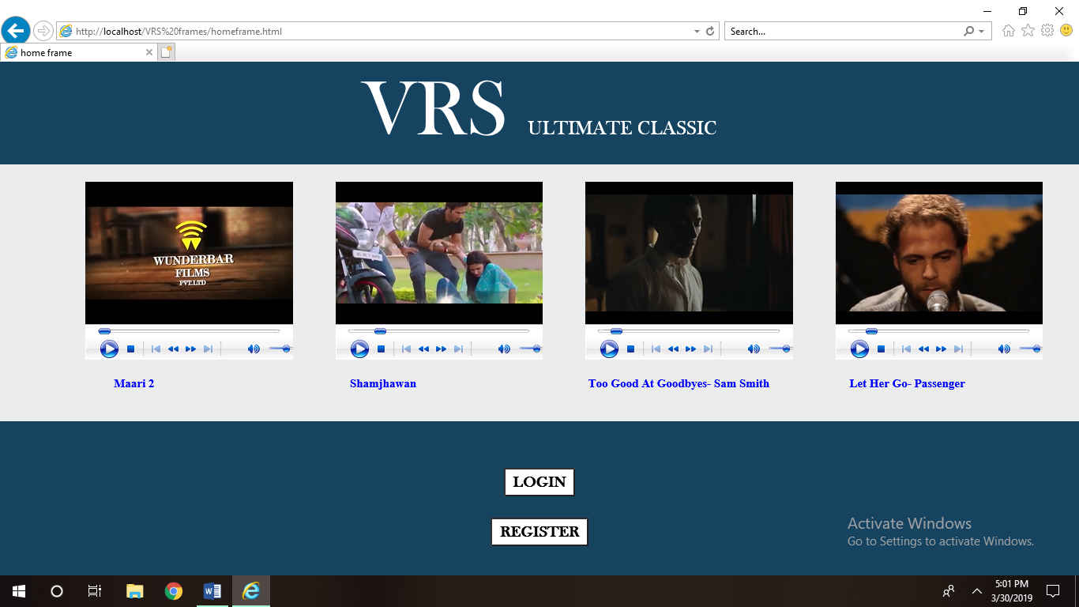

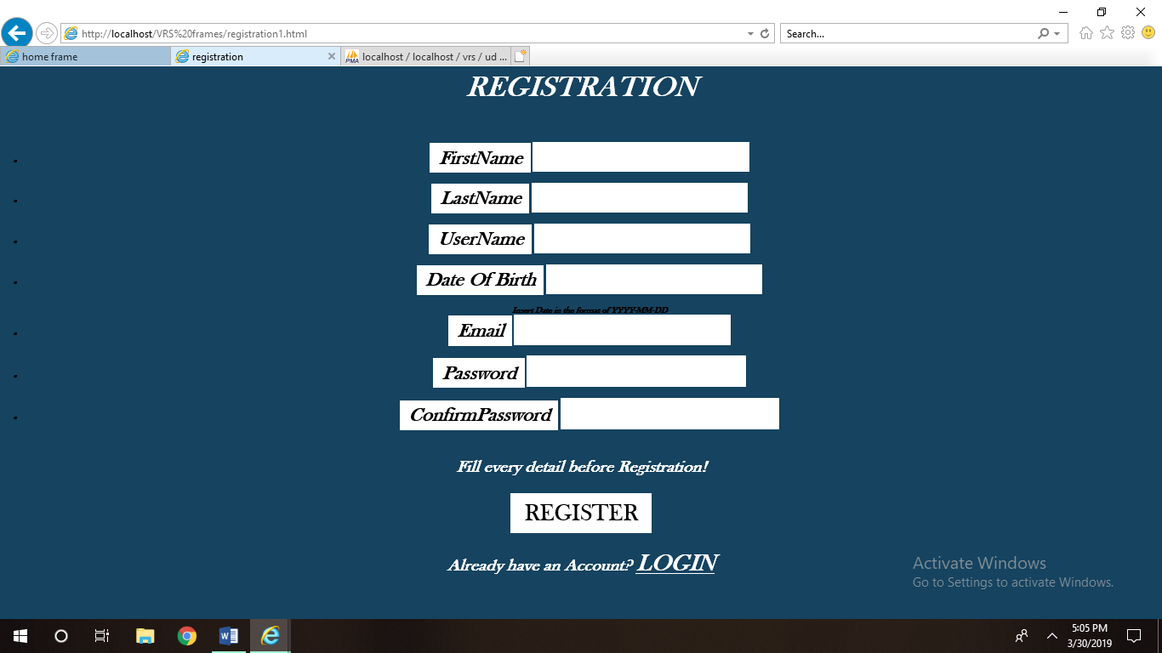

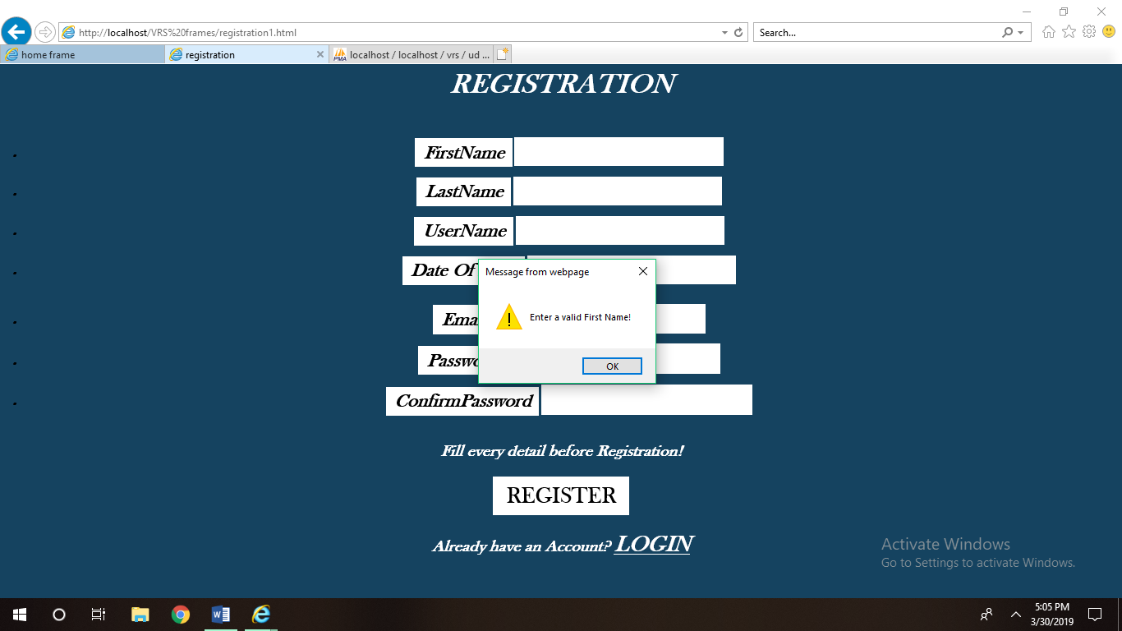

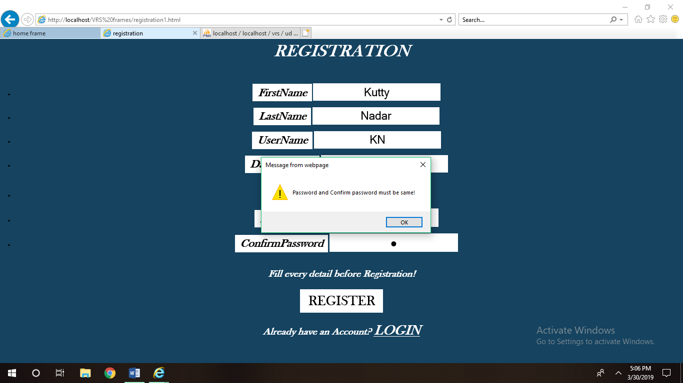

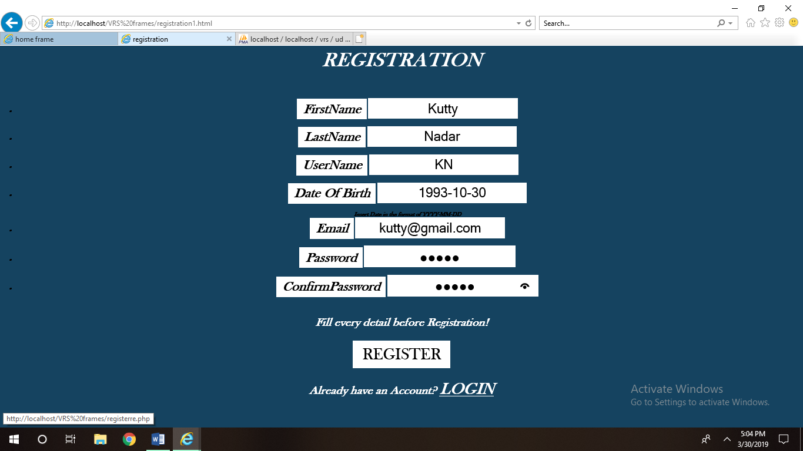

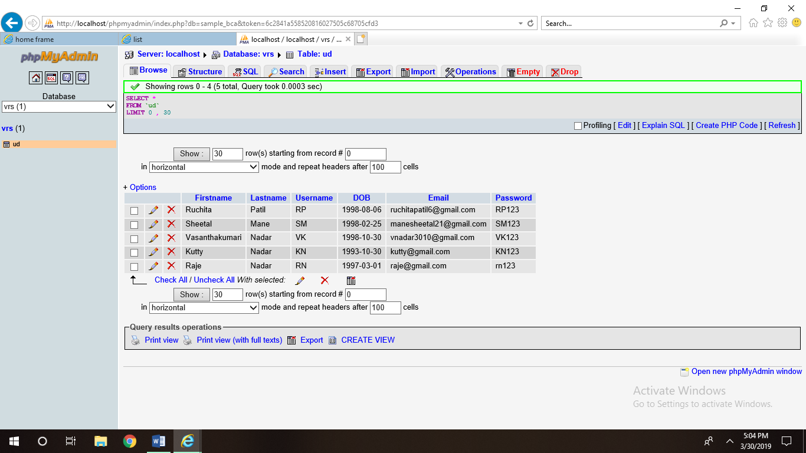

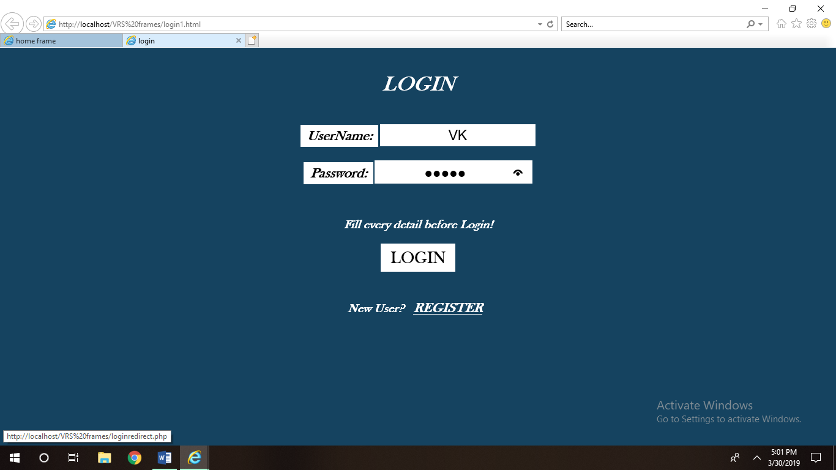

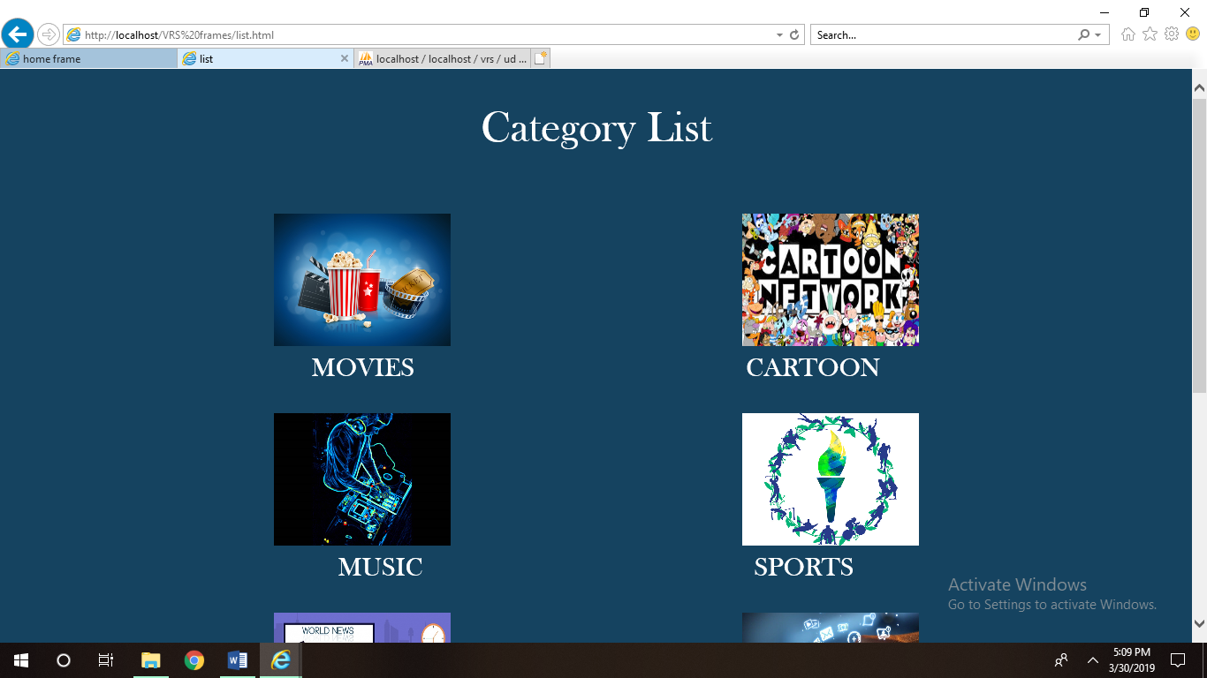

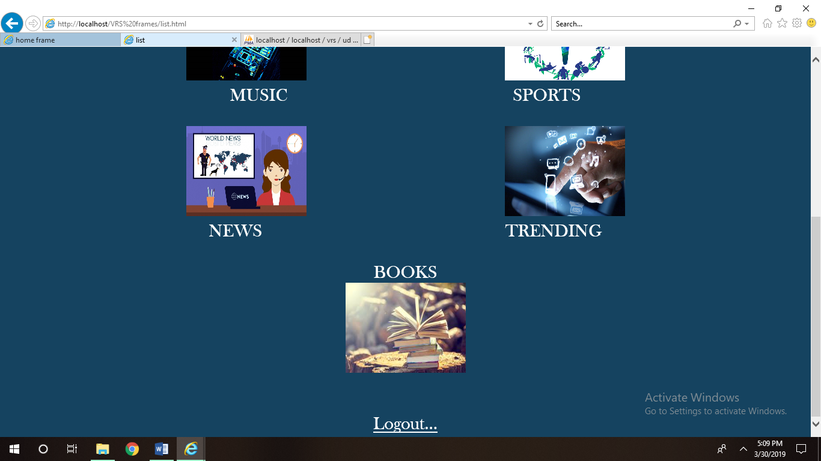

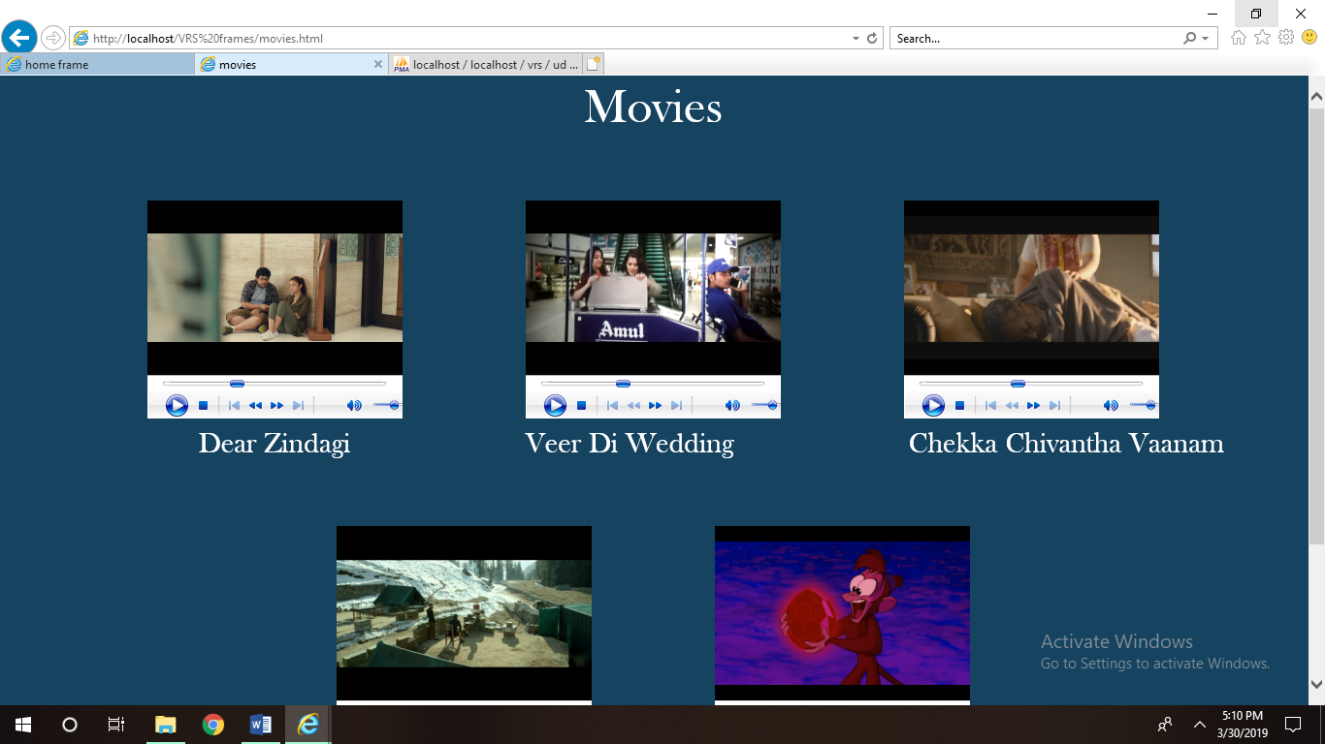

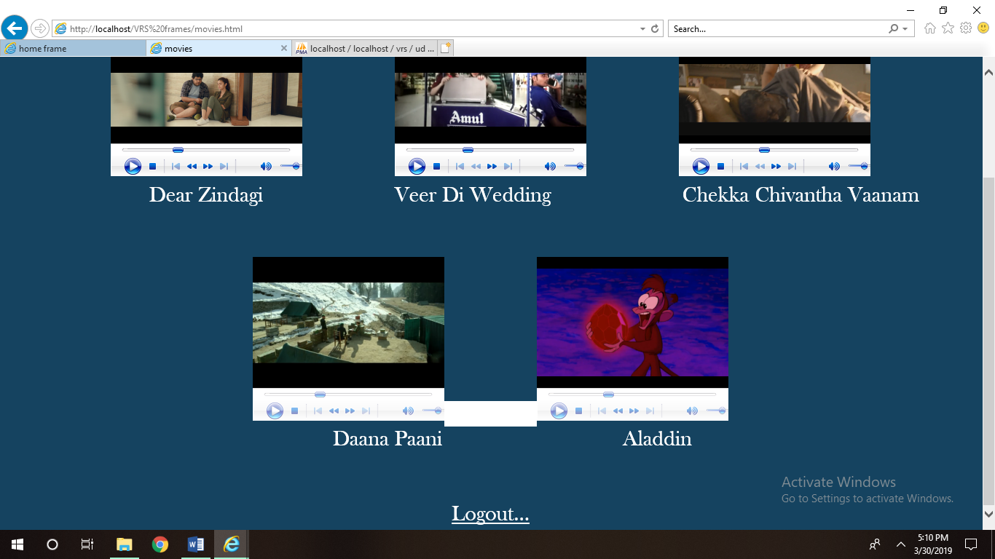

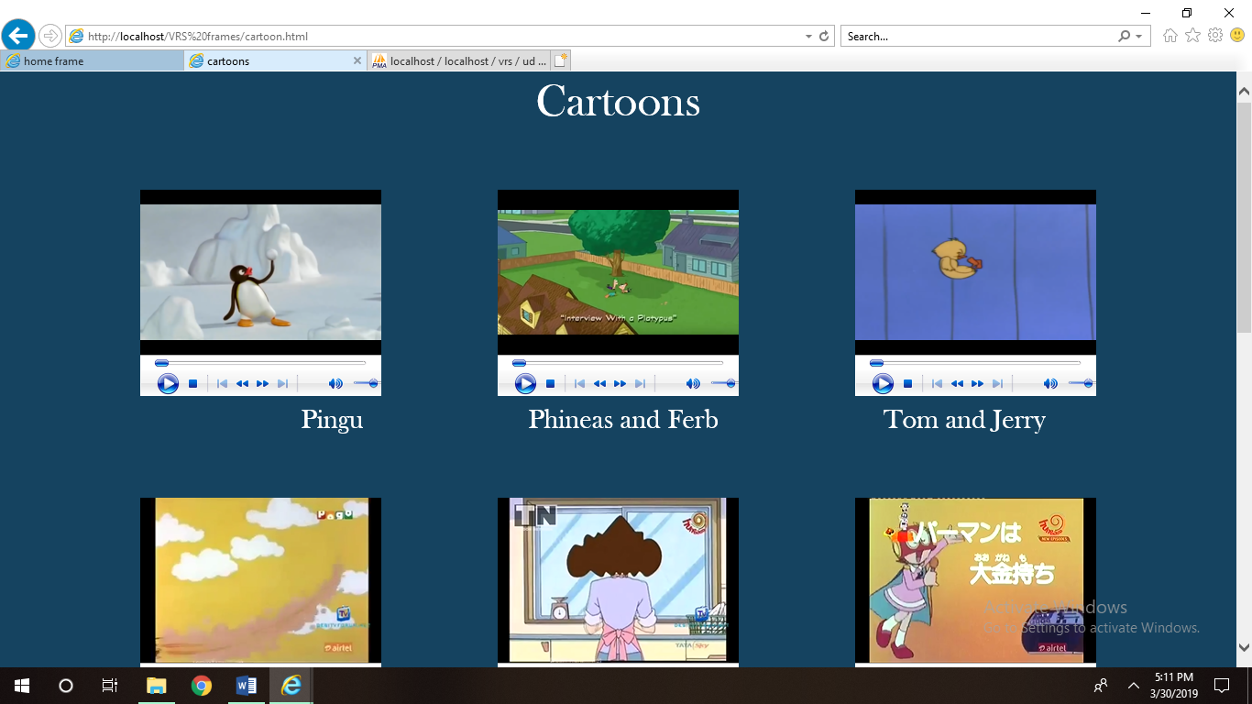

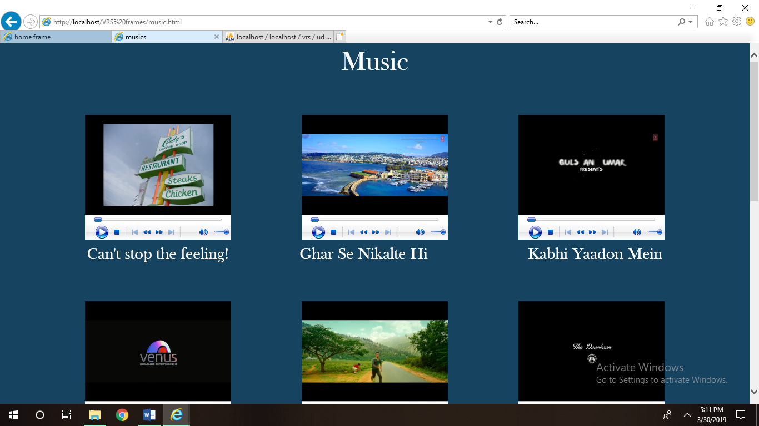

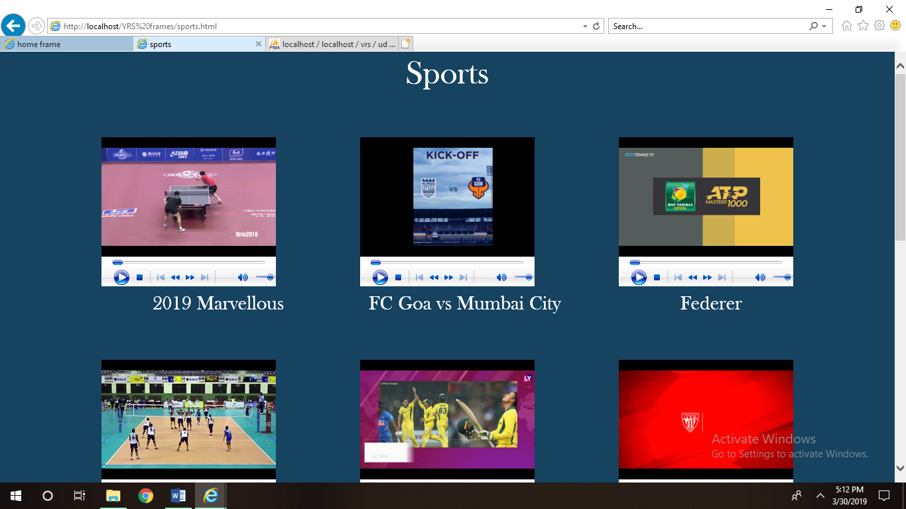

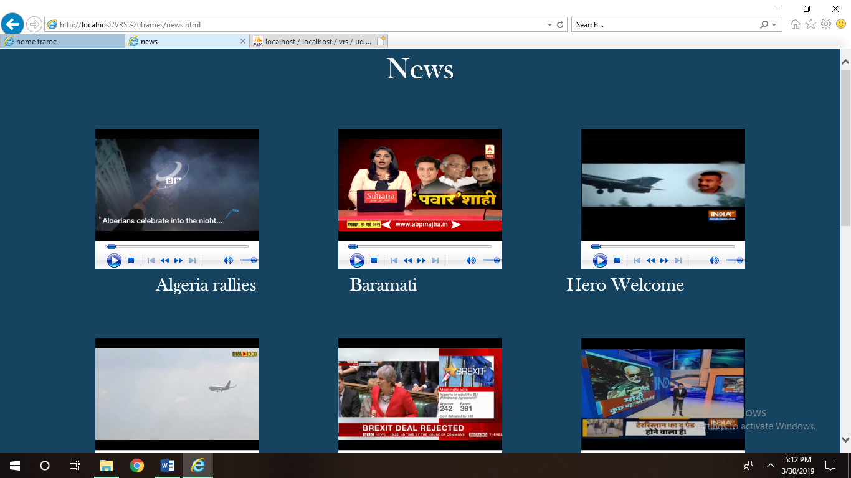

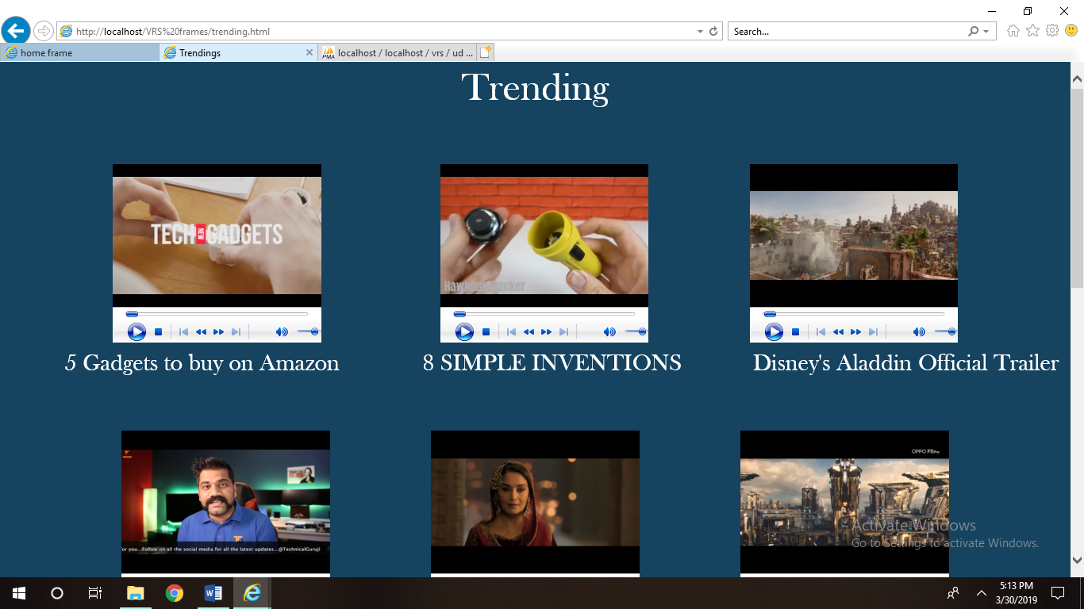

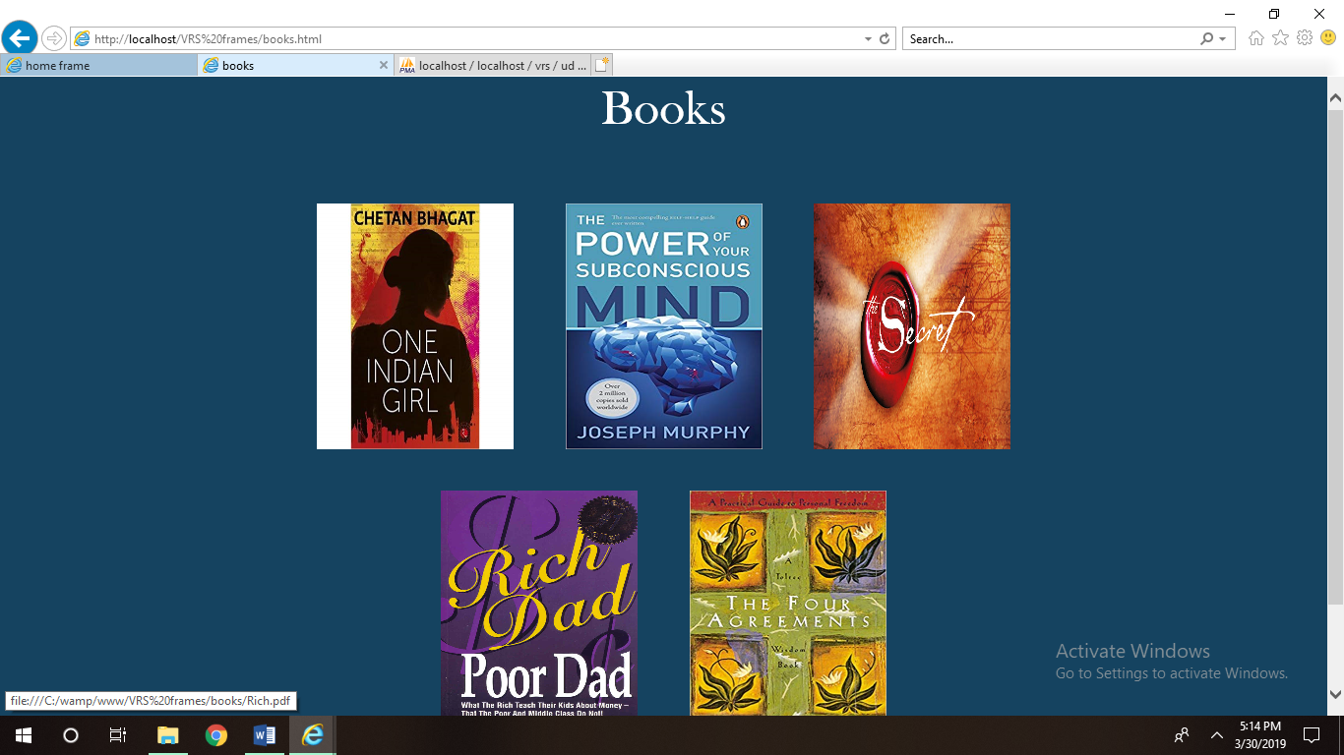

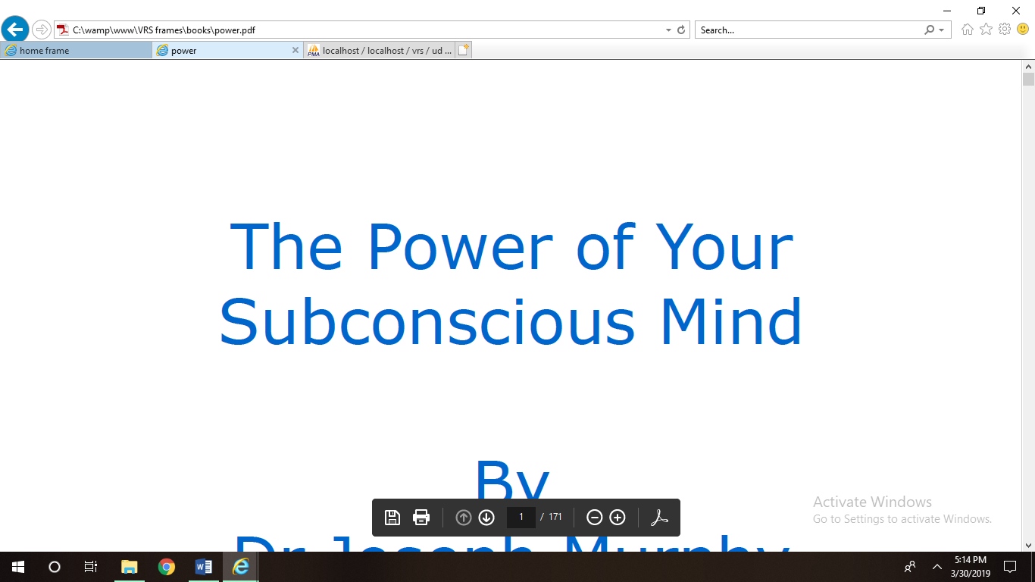

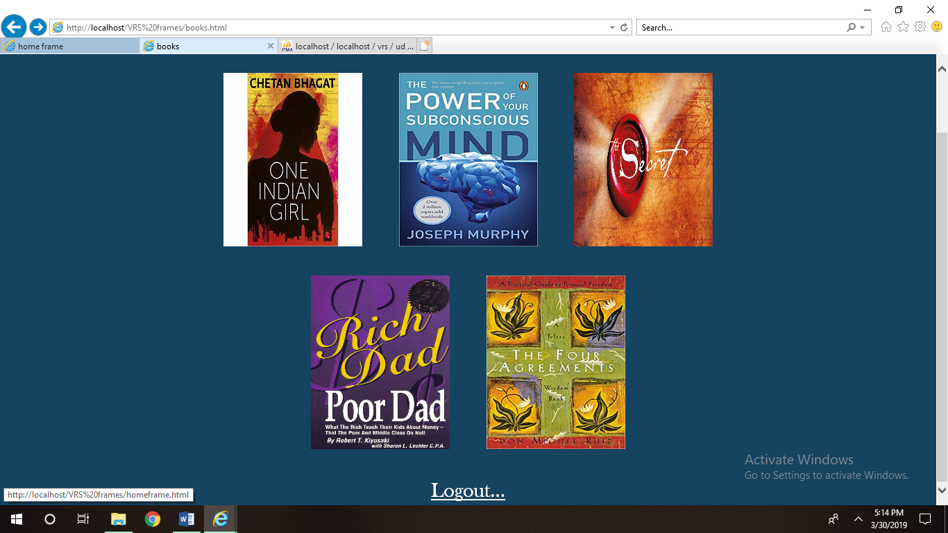

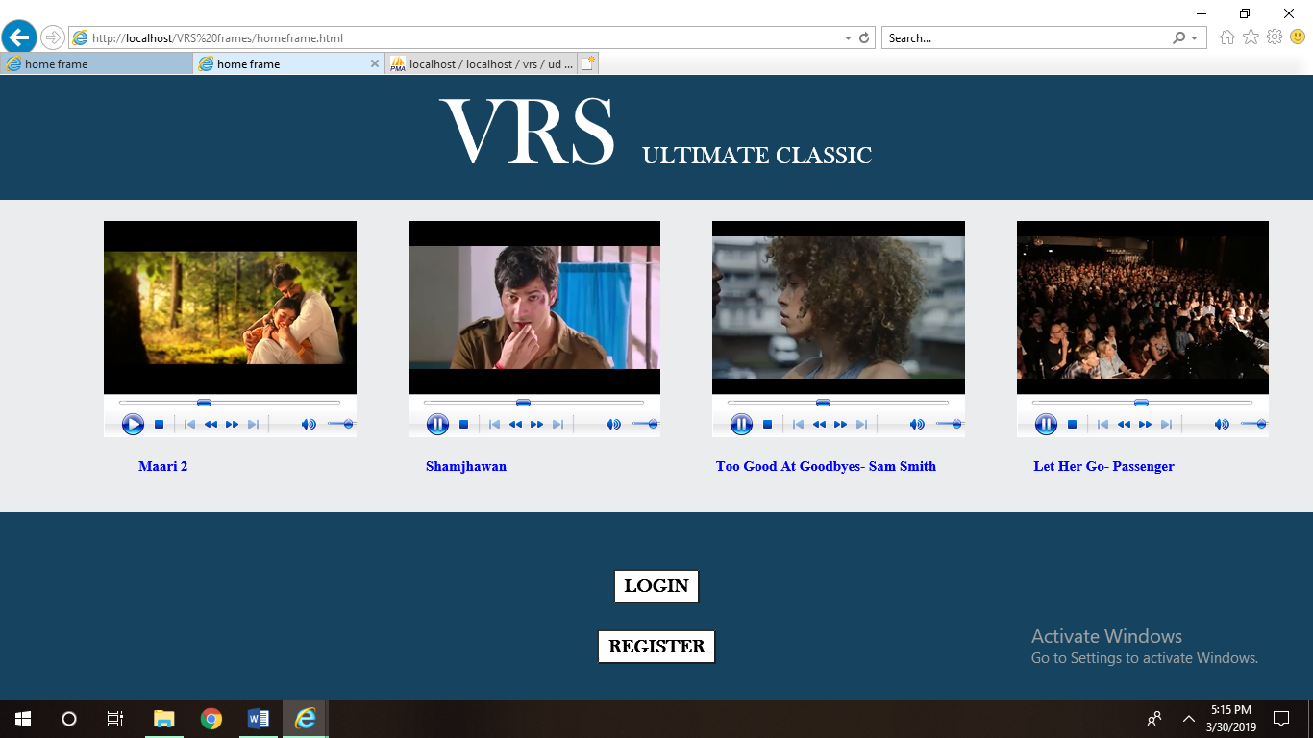

**CONCLUSION**

**Limitation:-**

There is nothing known as perfect. Every things has its own flaws. The project VRS Ultimate Classic is also bound with some limitation. They are explained further.

The feature that drive people crazy about Video streaming is Uploading, which is provided in feature scope of this project.

Share of video link to others is through copying the URL of the Video. Direct sharing is not yet updated.

Searching Videos through Names is a limitation, as user have to traverse and search the specific Video.

Mistakes while Login and Registration will lead to loss of previous filled data, which need to be filled again.

**Enhancement:-**

Developers can add extra features in the website as per necessity in the future for the fulfillment of their demands.

For security purpose, advanced encryption techniques can be used.

Creating new database as per increase in the users is possible.

**REFERENCES**

**Bibliography:-**

* Learning Web Design

Book by Jennifer Niederst Robbins

* PHP and MySQL for Dynamic Web Sites

Book by Larry Ullman

* Learning MySQL

Book by Seyed M. M. Tahaghoghi

* JavaScript and JQuery: Interactive Front-End Web Development

Book by Jon Duckett

* HTML & CSS: Design and Build Web Sites

Book by Jon Duckett

**Webliography:-**

<https://www.youtube.com>

<https://www.hulu.com/originals>

<https://vimeo.com/features/livestreaming>

<https://www.guru99.com/>

<https://www.tutorialspoint.com/>